K-ON! — Before Departure
Description | The night before March 16th, 2011, I dreamed about me and the gang going to some store and shopping for some souvenirs. The next day, I watched the gang ACTUALLY go to the store; I unfortunately could not be there. Now that I have adult money, I want to go to this store they went to and relive my dream. Can you find me the store name that they went to? I don't want the new store name ('cause who cares); I want the name of the retailer when the gang went there. (Which retailer used to run the shop associated with this scene?)
Files | image-01.jpg and image-02.jpg — two anime frames. Submit RCC{retailer}.  Anime images ©かきふらい・芳文社／桜高軽音部.
Hint(s) | 1. The girls are preparing to travel. Identifying the episode will help place these scenes.  2. The passport-office interior corresponds to the basement of Tokyo Metropolitan Government's Citizens' Plaza.  3. A Japanese visitor in 2017 recorded what a photo-service employee remembered about the previous shop.
Walkthrough | 1. Identify the travel-preparation episode, “Plan!” / 計画！, listed as season 2, episode 27. The episode listing describes the passport preparations that connect the two scenes.  2. Search けいおん 計画 旅券 聖地 for pilgrimage reports about the passport office. The September 17, 2017 visitor report places it on Citizens' Plaza B1 at the Tokyo Metropolitan Government complex. Match the glass corridor and yellow sign to image 2.  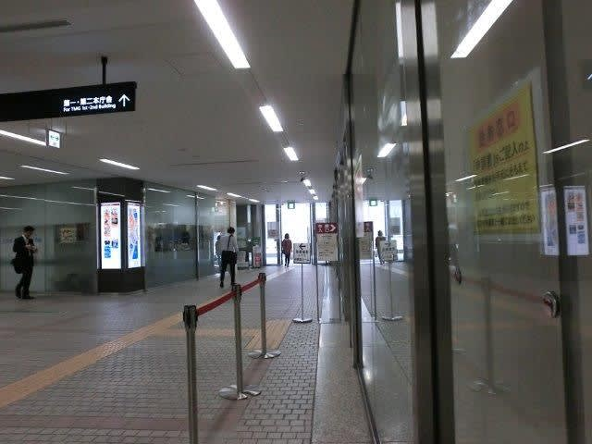  3. Read the paragraph beneath the Ritsu frame. The visitor reports that the later ID-photo area previously housed an Isetan travel-goods shop. The following shopping frame and paragraph connect that former shop to the anime scene. The retailer is 伊勢丹 — Isetan, not the photo service.  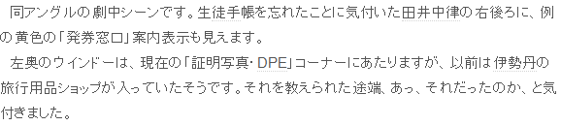  4. Corroborate the historical retailer on PDF page 2 of the official notice. It names 伊勢丹都庁総合売店 and places it beside the passport center on Citizens' Plaza B1. Submit RCC{isetan}.  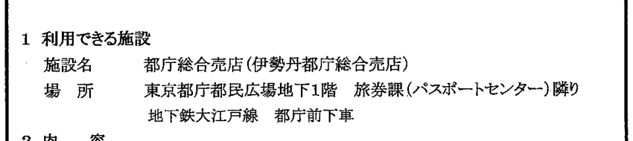
Flag | RCC{isetan}

